MEETING |  |  |  |  |  |  |  | 
Minutes of meeting n° 8 |  |  |  | 8 |  |  | 07/01/2026
Location : Penta Hotel City Center - Brussels |  |  |  |  |  |  | 07/01/2026
Distribution on 15/12/2025
Attendance | Present | Excused | Invited |  | Diffusion |  |  |  | Present | Excused | Invited | Diffusion
MO – Penta Hotel City Centre  Menno de Richemont | X |  | X |  | X | Contractor - NTSA  Thibault Fayd  Site supervisor (APO) |  |  |  | X  X | X  X | X  X
MOD – Immo-Pro (IP)  Olivier Fournier (OFO)  Leonardo Stefani (LST) – 0474/015.062 | X | X | X  X |  | X  X | Contractor – Pro4Finish (P4F)  Cedric Van der Burght |  |  | X |  | X | X
BET TS – TsfPlus  Grégoire Sillen |  | X | X |  | X | HSE coordinator – Whiteforge  Abdel Saifi |  |  |  | X | X | X
ARCH – De Bouwerij  Paul De Mulder  Iskra Bilic  Sofie | X  X | X | X  X  X |  | X  X  X | Contractor – Betico (BET)  Mourad Benja |  |  | X |  | X | X

Next meeting :

14/01/2026 at 11 :00 – On site Chau. de Charleroi nr. 38, 1060 Brussels

C General

C1 Approval of the previous minutes of meeting

Néant

C2 Information exchange

From whom | Status | Content | Due date
IP | To send | Photo report of the staircase | 18/10
P4F | Sent | P4F still needs to communicate the VAT number of the company. | 27/11
P4F | Sent | Updated technical data sheets for fire sealant and pictures of the fire seals already executed. | 27/11
ARCH | Sent | Photo report of level +6 ensuing the site visit on 03/12 | 10/12
P4F | Sent | Unit price for the new inspection hatches needed in the false ceiling (groundfloor and level +8) | 01/12
ARCH | To send | New compartmentation plans (first draft to be validated) | 31/01/2026

C3 Planning

Planning item
As of Monday 01/12, the fire detection of the hotel will be renewed
Floors out of service for fire detection PLANNING CONFIRMED
- +6, -2, -1 et REZ : 01/12 7 am – 05/12 (finalise lvl +6 by thursday 04/12 – Confirmed)
- +5, +4, +3 and +2 : 08/12 7am – 12/12
- +1, +7 et +8: 15/12 7am – 19/12
Level +5
- Floor back in service
Level +4
- 05/01/2026: Floor out of service
- 23/01/2026: Floor back into service
Level +3
- 26/01/2026: Floor out of service
- 13/02/2026: Floor back into service
Fire detection final audit
- Date to be confirmed (end of January)

D Discussed subjects

N° | Title | Subject – General | For whom | Due
04.01. | Maintenance works | - As the hotel is still in activity, maintenance works are still being carried out. The following works are currently not included in the scope of this project and are only part of the daily maintenance of the hotel:  - Regularisation of the fire sealings of existing and openings |  | Pro Memorie
04.02. | Check in at work | - The check in at work QR-code has been displayed at the entrance and at the lobby.  - All companies carrying out works on site related to the scope of works of the project are required to register all their workers via this QR-code or online via the project number.  - An excerpt of the registrations will be sent by all contractors to IP on a regular basis. |  | Pro Memorie
07.01 | Planning | - New planning to be issued with additional details concerning the fire detection works and finishing works.  - New planning was issued on 10/12 | MOD | DONE

N° | Title | Subject – Sprinklers | For whom |  | Due
06.01 | ANPI | A visit with ANPI is scheduled on the 28/12 to review the current layout and remaining remarks.  - Following the visit of ANPI several informal remarks were issued. Those remarks will be taken into account in the quote of phase 2 of the works. |  |  | Pro memorie

N° | Title | Subject – Finishings/Architecture | For whom | Due
04.05 | Technical data sheets | Pro4Finish has introduced technical data sheets, for approval by ARCH. | ARCH | 10/10
04.06 | Painting works level +7 | The painting works on level +7 will be carried out partly after the release of the level.  Pro4Finish will coordinate with the lobby to carry the necessary works in the rooms.  Meeting 27/11  - The finalisation of the works on level +7 will have to be carried out in the week of 15/12, while the fire detection is being renewed.  - The wall in the bedroom needs to be repainted, due to local damage during the installation of the sprinkler system in the following rooms: 711, 712, 715, 717, 718, 720, 721, 722, 724, 726, 729  Meeting 07/01/2026  - P4F will upload pictures of the finishing works executed on lvl +7 on the shared platform. | P4F  P4F | DONE  14/01/26
05.01 | Painting | - MO has sent photos of the painting works on level +7, which are not satisfactory. P4F will review and correct them.  - P4F will ensure that the subcontractor strictly adheres to the agreed execution dates going forward. | P4F | DONE
05.02 | Painting | - On the next levels, P4F will paint the areas in the corridor that become difficult to access once the collector pipes are installed, starting at the beginning of the sprinkler works. The painting works will proceed only after the floor protection has been put in place. | P4F | Pro Memorie
05.03 | On-site surveys | - ARCH will provide a quote for the local surveys on the Ground floor and for the compartmentation plans of the hotel.  - As soon as the quote is approved, ARCH will proceed with the surveys on site.  Meeting 27/11  - A separate order form will be issued for ARCH regarding new works not previously covered by the original scope signed in 2021. Remaining costs/invoices will be regularized directly with MO.  - The on-site survey can already start; the signed order form will be issued shortly.  - The drawings of the fire compartmentation plans can already start as well. | ARCH | DONE
06.02 | Level +8 ceiling works | ARCH will provide a proposition for the finishing works on level +8: Detail and cutting layout based on the current sprinkler layout.
07.01 | Finishing works phase 2 | - MOD will send a quick recap of the works to be included in phase 2 of the finishing works  - ARCH and P4F will do the necessary site surveys to provide a bill of quantities  - P4F will provide a quote based on that bill of quantities  Meeting 07/01/2026  - Bill of quantities for phase 2 will be provided by the end of January.  - The relevant finishing details (ceiling mouldings) and colour propositions will be issued by 16/01/2026. | MOD  ARCH | DONE  16/01/26
07.02 | Ceiling inspection hatches | Due to the installation of the new fire detection system, new inspection hatches are needed on the ground floor and level +8  - P4F has provided a unit price for 40x40 inspection hatches including the cut-out, provision and installation of the hatch. MOD has no remark on the unit price.  - The price of the inspection hatches will be included in the finishing works phase 2.  - The inspection hatches on the ground floor have already been cut out by the hotel staff (5 holes were cut out). P4F will install the inspection hatches by 05/12.  - The contractor Betico will provide a layout of the necessary inspection hatches on level +8.  - P4F will install the inspection hatches by Thursday 11/12 EOD, at the latest. Provided that the layout plan was sent before 05/06 to P4F.  - ARCH will provide a proposition for the painting works of the ceiling hatches (local detail) to prevent the necessity to paint the whole ceiling.  Meeting 07/01/2026  - The inspection hatches will be finalized by 16/01/2026 on levels +8 and ground floor.  - Some (+-5) inspection hatches will need to be replaced by a 60x60 format instead of the 40x40 format. The structure above is not suited for the placement of the small format of hatches. | P4F  P4F  BETICO  P4F  ARCH  P4F | DONE  DONE  DONE  11/12  10/12  16/01/26
08.01 | Temporary fire doors and walls | On the request of the fire brigade, a temporary fire door and wall will be installed at the 15m limit in the corridor (dead end). The rooms behind this fire wall will be out of service until the end of the sprinkler works.  - P4F will provide a planning for the execution of the works  - The doors will be delivered on site around the end January/start of February  - The fire wall can already be executed while waiting for the doors (dates to be provided in the planning)  - The doors will not be painted. The additional options for the doors are not retained.  - The wall will be painted (same color as corridor) on one side only! | P4F | 16/01/26
08.02 | Painting works +6 | - Painting works in the corridor on lvl+6 were finalized.  - Room 609: damaged wall still to be painted.
08.03 | Painting works +5 | Painting status of level +5 still needs to be assessed with the architect on site.  - P4F will upload the pictures on the shared platform

N° | Title | Subject – Fire detection | For whom |  | Due
08.04 | Fire detectors in the rooms | The fire detectors in the rooms are being replaced by fire detectors with integrated alarms.  The modification has started and will be finished by Wednesday 14/01/2026, depending on the availability of the rooms.  The fire detection system being modified on levels +2, +3, +4, +5, and +6 will be temporarily kept out of service until the 14th of January 2026 in order to prevent warnings on the central unit. The programmer will reinstate the system after the modification.
08.05 | Fire detection controls | Betico awaits the information on all the controls that need to be taken into account.  IP will follow up with the engineering office Concept Control to provide the necessary information. |  | IP | 16/01/26
08.06 | Communication with central unit of the parking | IP will contact the parking to know the position of the central unit which needs to be connected to the central unit of the hotel. |  | IP | 16/01/26

E. Appendices
Indications on plan, see sketch here under:
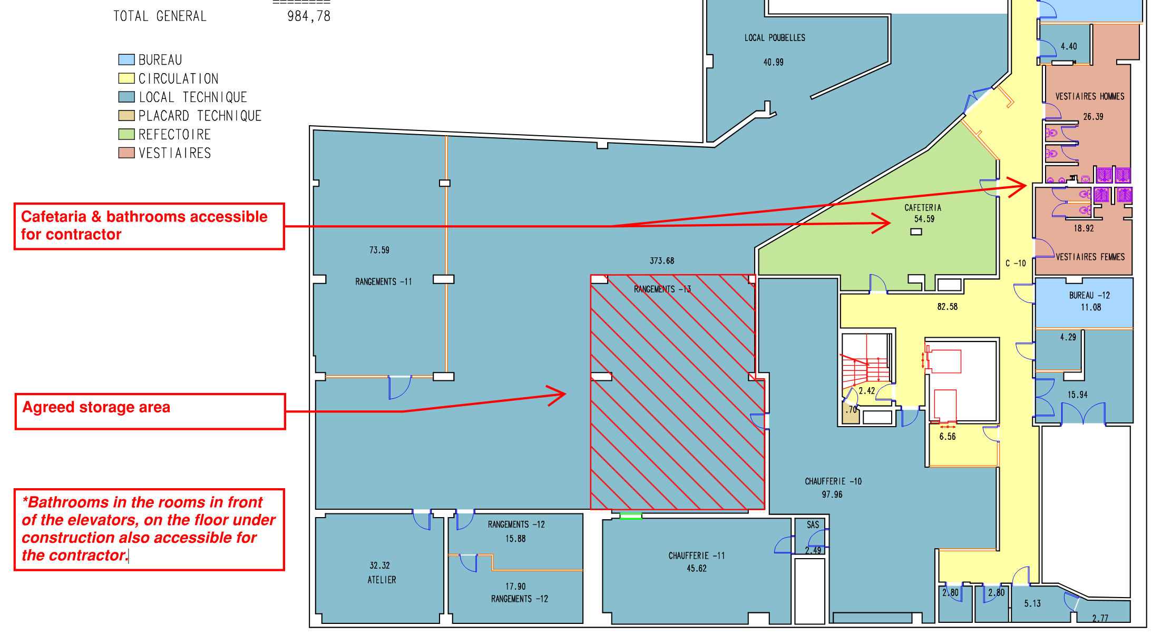

F. General remarks
This report will be subject to approval at the beginning of the next meeting; however, any corrections may be made upon receipt of it.

End of this report.

